Working with Categorical Data
Introduction
Categorical Data - Features having a specific set of possible values.
Numerical Data - Features represented as integers or real-valued numbers.
Vocabulary and One-hot Encoding
Categorical Data - Features having a specific set of possible values.
Dimensions - The number of entries in a feature vector.
Discrete Feature - A feature with a finite set of possible values.
Feature Cross - A synthetic feature formed by "crossing" categorical or bucketed features.
Feature Vector - The array of feature values comprising an example.
Hashing - In machine learning, a mechanism for bucketing categorical data, particularly when the number of categories is large, but the number of categories actually appearing in the dataset is comparatively small.
One-hot Encoding - Representing categorical data as a vector in which one element is set to 1 and all other elements are set to 0.
Sparse Feature - A feature whose values are predominately zero or empty.
Sparse Representation - Storing only the position(s) of nonzero elements in a sparse feature.
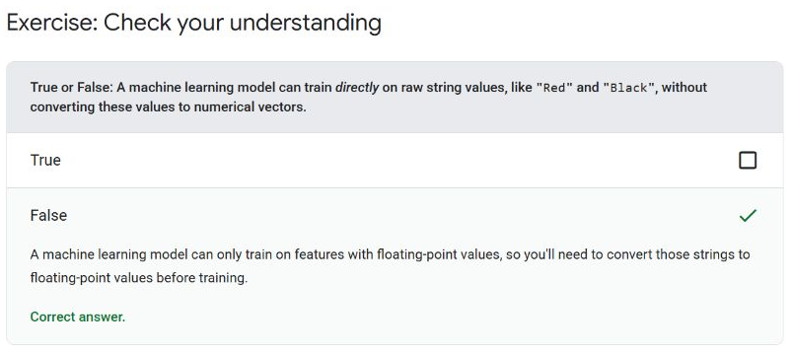
Common Issues with Categorical Data
Inter-rater Agreement - A measurement of how often human raters agree when doing a task.
Feature Crosses
Feature Cross - A synthetic feature formed by "crossing" categorical or bucketed features.
Neural Network - A model containing at least one hidden layer.
Feature Cross Exercises
Exercise 1
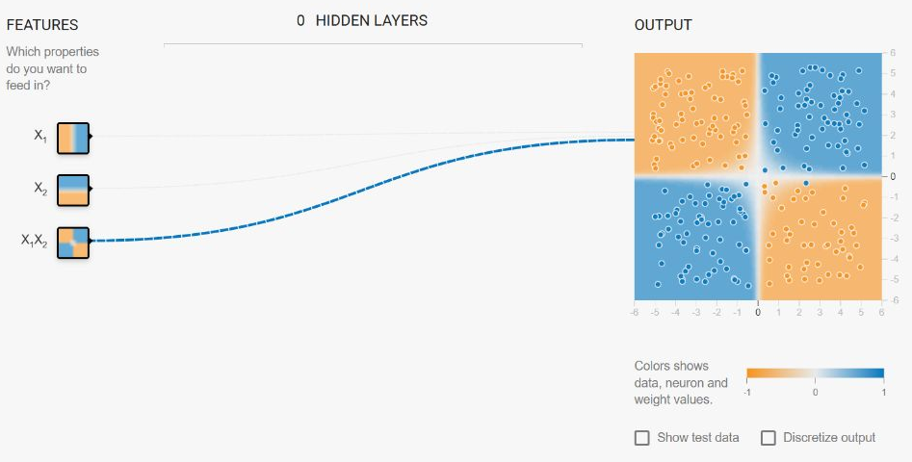
Exercise 2
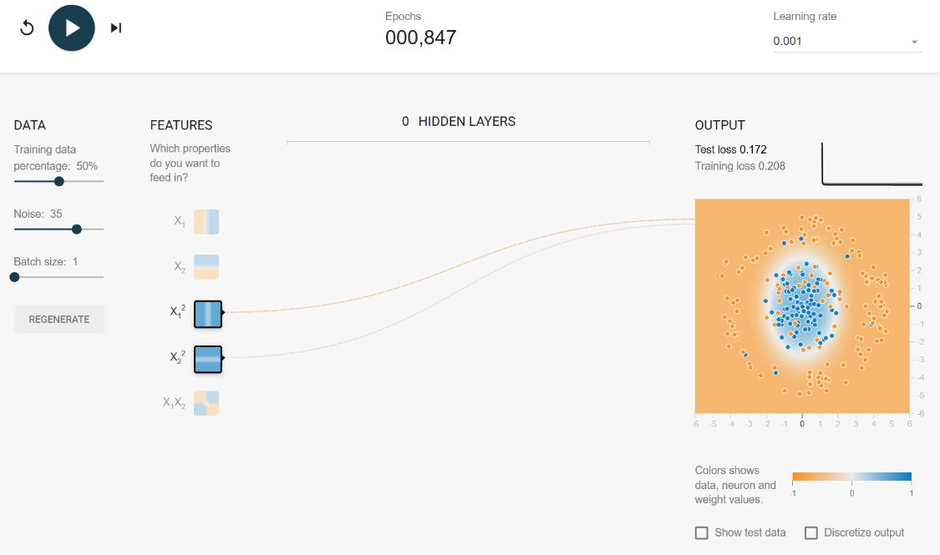
Test Your Knowledge


